**CS225-226 Project:-**

**Topic: *Arduino Nano Based “Lie Detector”***

# Motivation:-

There are a lot of small things for which we lie in our daily lives, like why we got late, who broke the glass, who ate the ice-cream, etc. So, in order to figure that out, I made a small portable lie detector for myself so if someone lies to me, I can check on it 😊….

# Introduction & Working Principle:-

Lie Detector is a fun, digital-design Arduino based project. Usually when someone lies, they get nervous, that is the “fundamental idea” behind my lie detector.

Our skin is amazing! It provides a medium for us to experience the sense of Touch, it keeps infections out and not only that, our skin changes conductivity depending on many different things, one being our mood. It is called Electro Dermal Activity (EDA). EDA is the property of the human body that causes continuous variation in the electrical characteristics of the skin.

The traditional theory of EDA tells that skin conductance varies with the state of sweat glands in the skin. And Sweating is controlled by the sympathetic nervous system, so whenever we get nervous, our sweat gland activity also increases, which in turn increases skin conductance. In this way, skin conductance can be a measure of emotional and sympathetic responses. More information can be found here - <https://en.wikipedia.org/wiki/Electrodermal_activity> .

So if someone tries to lie with his/her fingertips connected to the lie detector and he/she gets nervous, then the skin conductivity will increase suddenly which can be noticed in the serial plotter in the Arduino IDE and the Red LED will start glowing thus indicating that the subject is trying to lie.

## Components and Supplies:-

* Arduino Nano:- The Arduino Nano is a small, complete, and breadboard-friendly board based on the ATmega328. The Arduino Nano can be powered via the Mini-B USB connection.

Each of the 14 digital pins on the Nano can be used as an input or output, using pinMode(), digitalWrite(), digitalRead(), analogRead() functions. They operate at 5 volts. The Arduino Nano can be programmed with the Arduino IDE software.

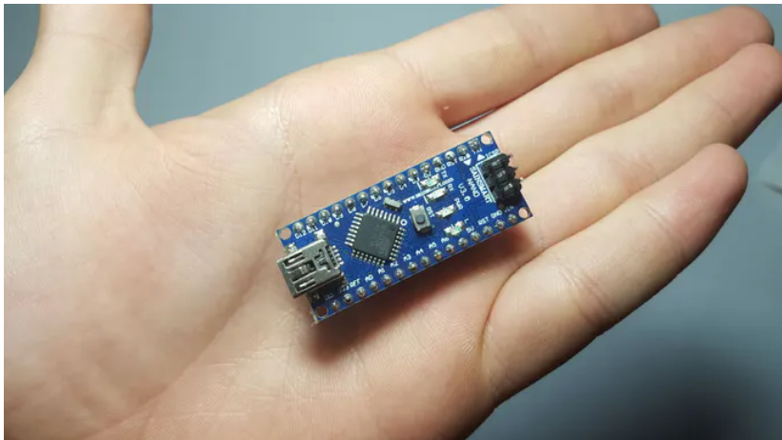

* Breadboard:-

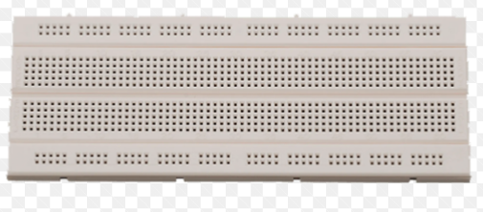

A breadboard is a solder less rectangular plastic board with a bunch of tiny holes in it. These holes let us easily insert electronic components to prototype (meaning to build and test an early version of) an electronic circuit. Most electronic components in electronic circuits can be interconnected by inserting their leads or terminals into the holes and then making connections through wires where appropriate.

* Cables:-

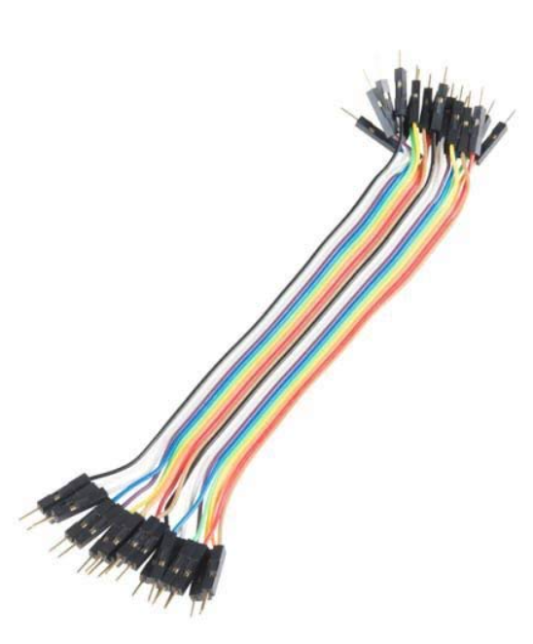

Jumper wires typically come in three versions: male-to-male, male-to-female and female-to-female. The difference between each is in the end point of the wire. Male ends have a pin protruding and can plug into things, while female ends do not and are used to plug things into. Male-to-male jumper wires are the most common and they are what I have used to build my lie detector circuit. When connecting two ports on a breadboard, a male-to-male wire is what we need.

* Green, Red and Orange LEDs:-

These LEDs are used to visually show our device’s prediction that whether the subject is lying or not.

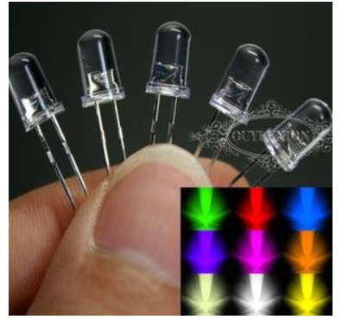

* 1800 ohm Resistor:-

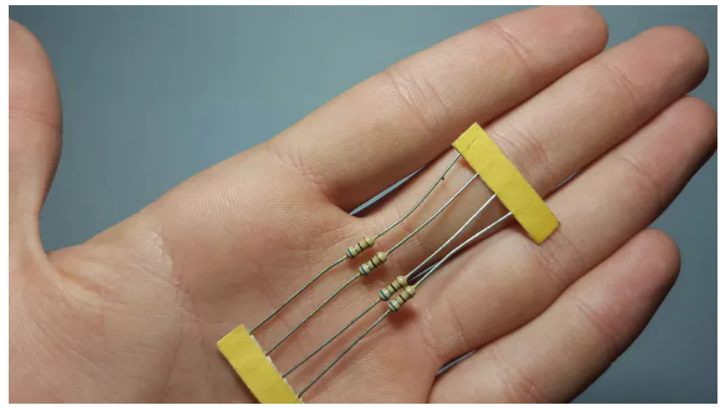

The resistor provides a voltage drop and thus helps to ensure that the LEDs don’t fuse due to excessive voltage.

* A to mini B USB data cable:-

Used to connect Arduino nano board with laptop and upload code on it.

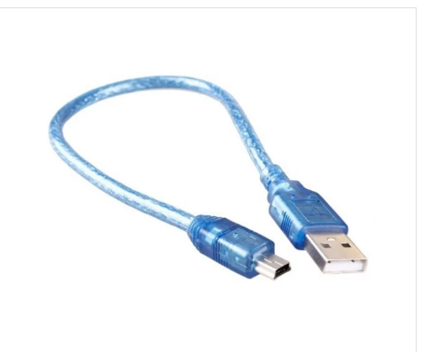

* Battery Cap:-

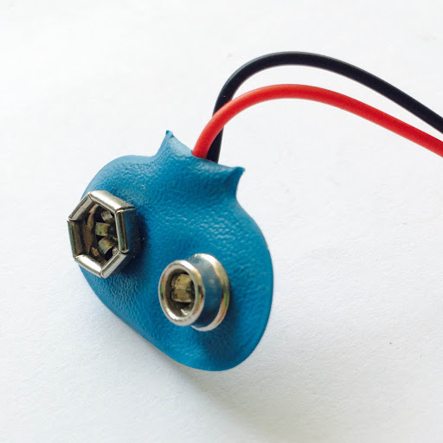

The battery cap is used for efficient connection between the fingertips and the wires from analog0 pin and 5V pin of the arduino nano board.

* Apps and Online Services:-



The Arduino Integrated Development Environment - or Arduino Software (IDE) - contains a text editor for writing code, a message area, a text console, a toolbar with buttons for common functions and a series of menus. It connects to the Arduino hardware to upload programs and communicate with them. The open-source Arduino Software (IDE) makes it easy to write code and upload it to the board. This software can be used with any Arduino board.

## Making the Circuit:-

The wiring for this is nice and simple, I started by connecting them in this order:

1. First of all connecting the Arduino Nano board to the breadboard. For that there are two ways:

(i) By directly inserting the Arduino Nano into the breadboard.

(ii) By connecting the required pins of the Arduino Nano to the breadboard with the help of female to male jumper wires.

I have followed the first one for better visibility & clarity of my circuit using lesser number of wires.

2. Connect a piece of cable to Analog pin 0 of the Arduino.

3. Connect A piece of cable to 5 volt pin of the Arduino.

4. Connect one end of an 1800 ohm resistor to ground and other to extended analog 0 pin.

5. Connect the anode (long leg) of the green led to pin 2 of the Arduino and the cathode (short leg) to ground.

6. Connect the anode of the orange led to pin 3 of the Arduino and the cathode to ground.

7. Connect the anode of the red led to pin 4 of the Arduino and the cathode to ground.

8. Lastly, we connect the wires extended from Analog0 pin and 5V pin of the arduino to a battery cap so that we can place the subject’s fingers on the battery cap probes for easy and efficient connection.

That's all the wiring for the lie detector.

### Block Diagram:-

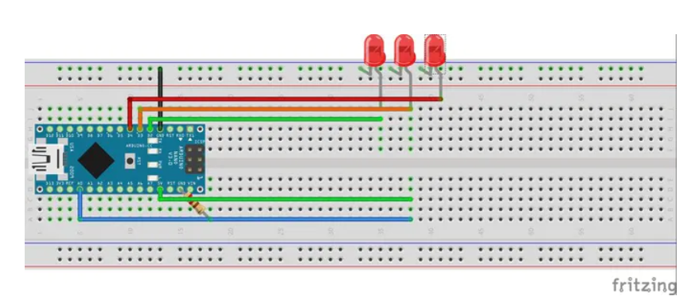

## Software and Code:-

The main piece of software I used is the newest version of Arduino IDE.

I connected my Arduino Nano with my laptop using a USB data cable and then selected the correct board type, processor and port and then uploaded the code on it.

The code snippet is given below:-

I have added comments within the code for better understanding.

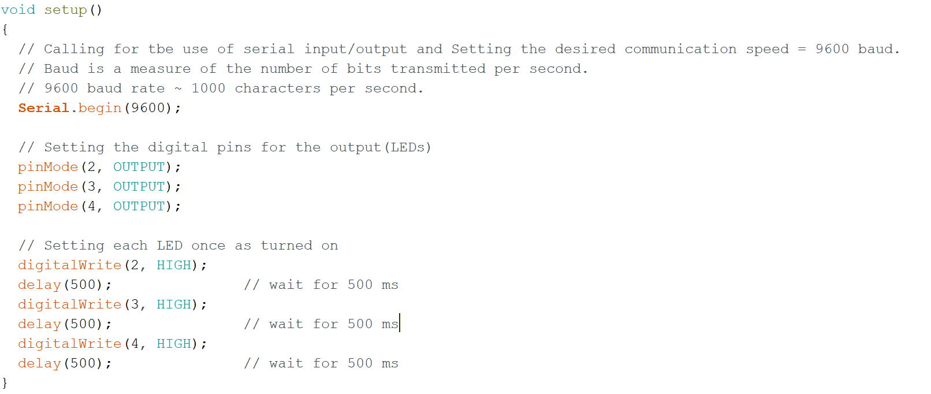



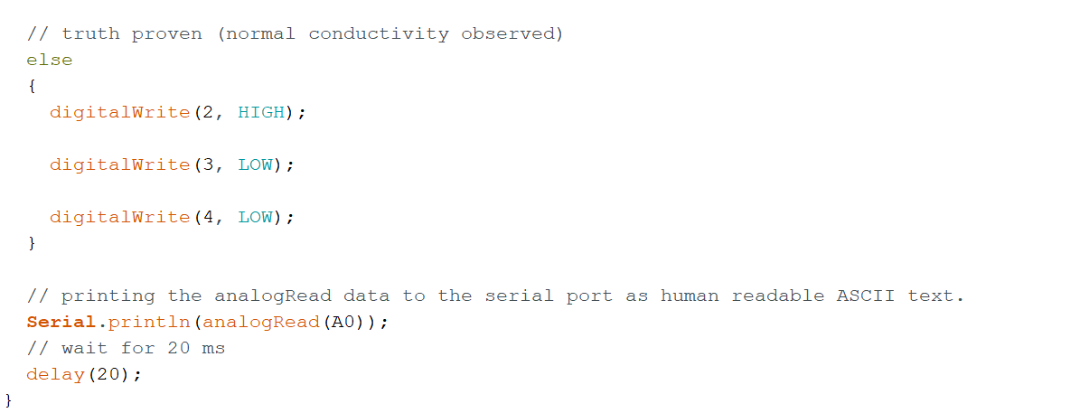

The data being received from the Arduino, can be displayed in a real time graph which will help us identify when the data changes its pattern (when someone lies :D).

#### Normal Skin Conductivity plot:-

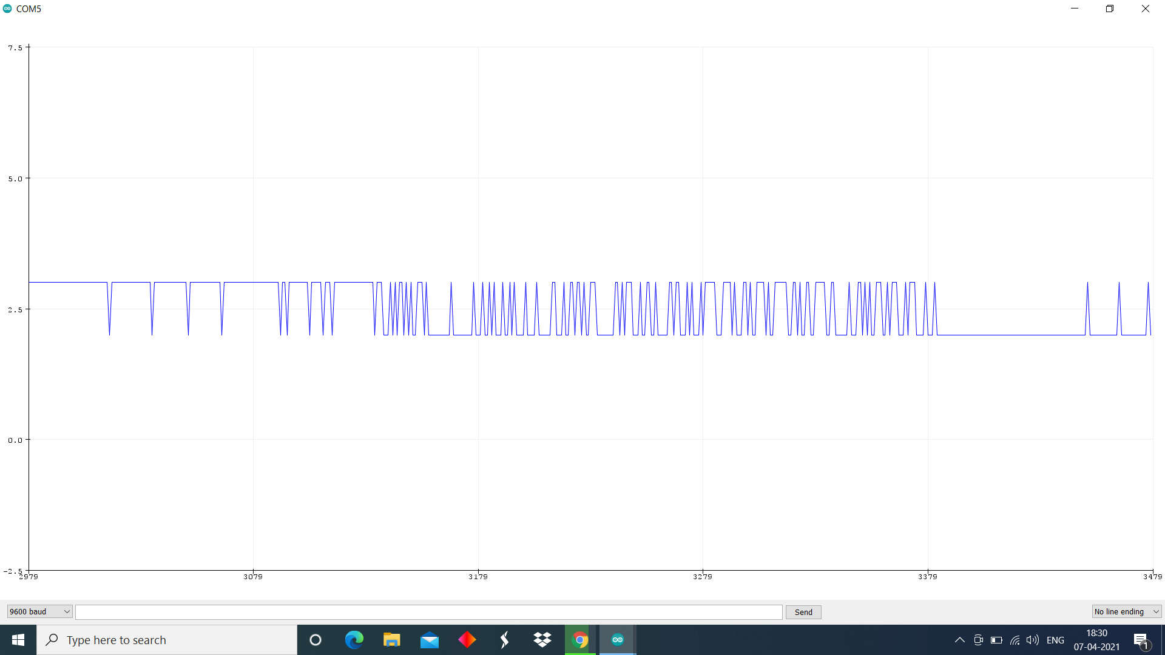

Higher than usual conductivity plot (When the subject is a bit nervous):-

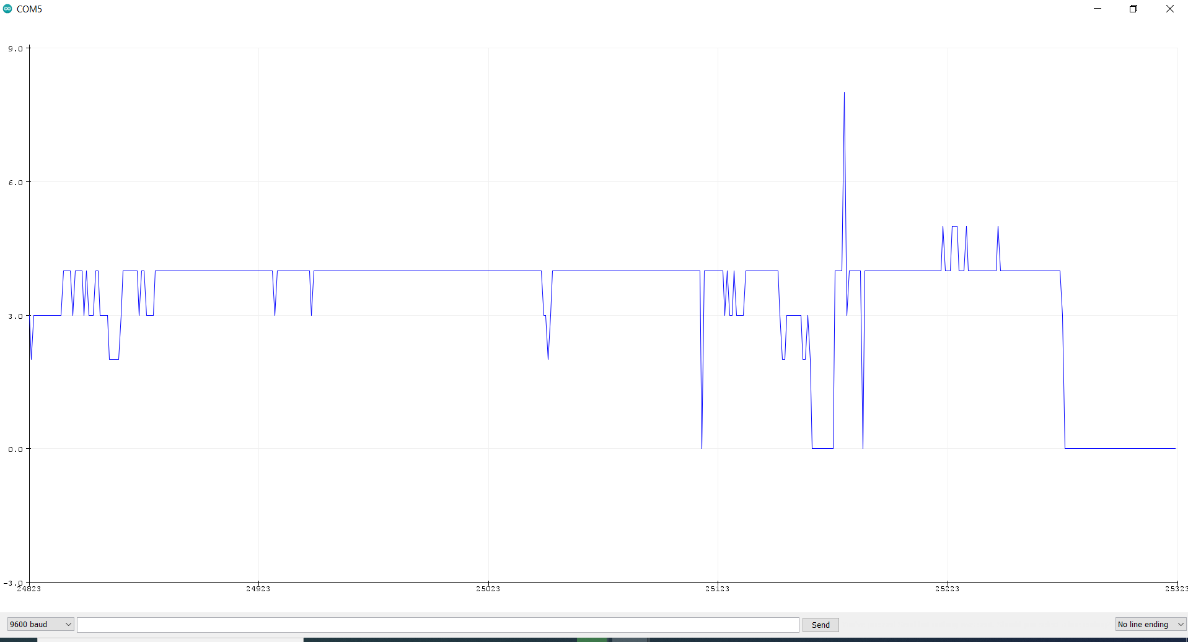

The skin conductivity values can also be seen in the serial monitor of Arduino IDE as integers.

Serial Monitor Snap:-



## Testing on subjects:-

The Arduino Nano is powered by a data cable from the laptop, and it uses the power to maintain a constant potential difference across the part of skin connected to the circuit using battery cap probes.

We start by asking some simple questions from our subject such as name, age, etc, and observe the graph in the serial plotter in Arduino IDE to get the base line of the skin’s conductivity and upload the corresponding valued code to the arduino board. Now, we can start asking other questions to our subject for which he/she may lie about. When the subject lies, he/she will “probably” feel nervous and the value in the graph will increase sharply and the red LED starts glowing thus we can conclude that he/she is lying.

## My Demo:-

* Truth Proven 😊:-

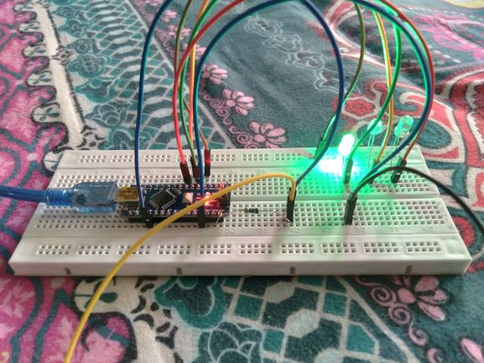

* Lie Caught ☹:-

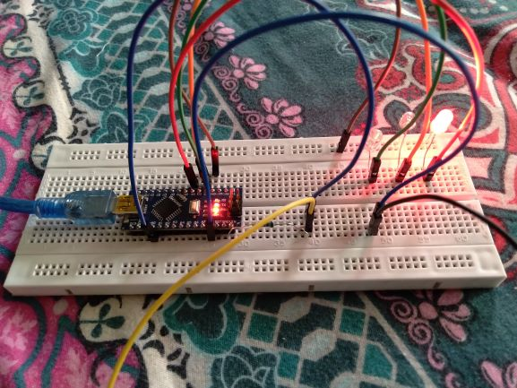

## Critical Analysis:-

As written in the introduction section, this lie detector works on the principle that most “probably” one gets nervous while telling a lie.

When one gets nervous, the sweat gland activity increases which in turn increases the skin conductivity which we measure to determine whether the subject is lying or not.

The Arduino IDE provides a really cool way of seeing this through the serial plotter and we can see the conductivity values using the serial monitor as well.

There are some points which need to be kept in mind during our testing:-

1. Firstly, since everything is based on skin, its contact with the battery cap probes must be proper & uniform.

2. The state (condition) of the fingers must be the same throughout the process. For example, I have seen that if the fingers are wet, the conductivity values become quite large than normal.

3. Also, I have observed that as the number of questions asked increases, subjects tend to get more nervous so the conductivity values start increasing a bit. To accommodate this, one can wait for some time in between the questions or update the values in the code and upload it again to the board.

After taking all these precautions, the lie detector usually works fine but still, What I have made is a small portable Arduino lie detector which isn’t the most accurate system. In fact, in most real lie detectors, a host of other sensors are used to determine if someone is lying such as a heart rate monitor. What I am saying is one should not use the result of this lie detector for serious questions.

## Challenges faced (Lessons Learnt):-

When I first received the breadboard and Arduino Nano board then I started by trying to insert it into the breadboard which I was not able to do due to the poor quality of the breadboard. So I searched for this issue and learnt to connect it using female to male jumper wires instead of directly inserting it into the breadboard. Although later I was able to insert it which provides a better, clearer view of the circuit. Then I made the entire circuit and connected the nano board to my laptop using type A to mini B USB data cable but the indicator light in the arduino board didn’t glow. So I wondered what could be the reason. After struggling for some time, I found out that the arduino board was defective. So for quick access, I had to buy a new one from the local market, which required much effort.

## Alternatives:-

1. Firstly, As I wrote above, the Arduino Nano board can also be connected to the breadboard by using female to male jumper wires.

2. Secondly, the entire circuit can be soldered using soldering iron instead of making it on a breadboard.



3. The model can also be built using Arduino Uno, I have used nano board due to its lesser cost and smaller size.

THANK YOU